- Java Date and Time:
#code:
import java.io.*;
import java.math.*;
import java.security.*;
import java.text.*;
import java.util.*;
import java.util.concurrent.*;
import java.util.function.*;
import java.util.regex.*;
import java.util.stream.*;
import static java.util.stream.Collectors.joining;
import static java.util.stream.Collectors.toList;
import java.time.LocalDate;

class Result {
/*
* Complete the 'findDay' function below.
*
* The function is expected to return a STRING.
* The function accepts following parameters:
* 1. INTEGER month
* 2. INTEGER day
* 3. INTEGER year
*/
public static String findDay(int month, int day, int year) {
LocalDate date = LocalDate.of(year, month, day);
return date.getDayOfWeek().toString();
}
}

public class Solution {
public static void main(String[] args) throws IOException {
BufferedReader bufferedReader = new BufferedReader(new InputStreamReader(System.in));
BufferedWriter bufferedWriter = new BufferedWriter(new FileWriter(System.getenv("OUTPUT_PATH")));

String[] firstMultipleInput = bufferedReader.readLine().replaceAll("\\s+$", "").split(" ");

int month = Integer.parseInt(firstMultipleInput[0]);
int day = Integer.parseInt(firstMultipleInput[1]);
int year = Integer.parseInt(firstMultipleInput[2]);

String res = Result.findDay(month, day, year);

bufferedWriter.write(res);
bufferedWriter.newLine();

bufferedReader.close();
bufferedWriter.close();
}
}

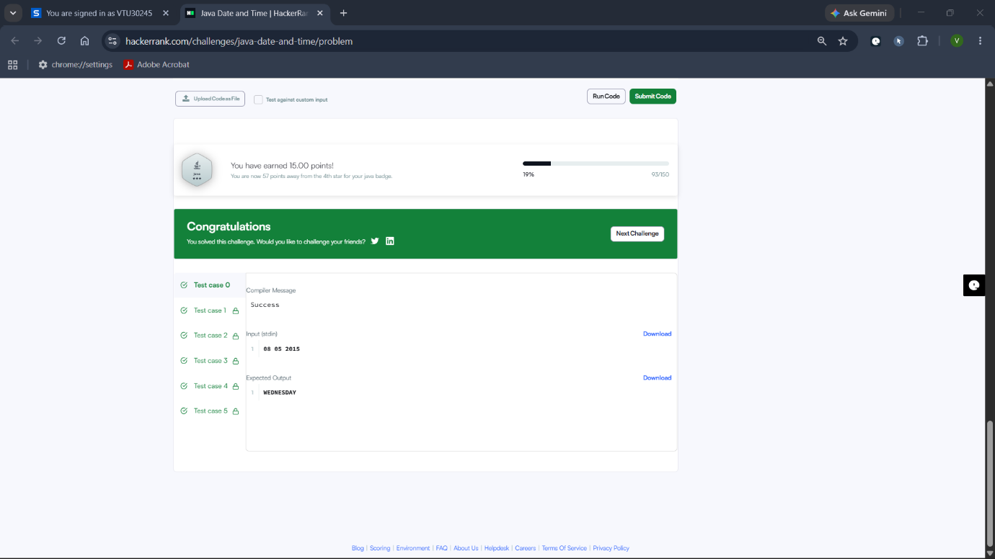

- Number of Days Between Two Dates:
#code:
import java.time.LocalDate;
import java.time.temporal.ChronoUnit;

class Solution {
public int daysBetweenDates(String date1, String date2) {
// Parse the string dates into LocalDate objects
LocalDate d1 = LocalDate.parse(date1);
LocalDate d2 = LocalDate.parse(date2);

// Calculate the absolute difference in days
return (int) Math.abs(ChronoUnit.DAYS.between(d1, d2));
}
}
